Technical Report - Project specifications

aLIVE

|  |  |
| --- | --- |
| Course: | IES - Introdução à Engenharia de Software |
| Date: | Aveiro, <date of submission> |
| Students: | 89059: João Carvalho  92952: Rui Fernandes  93102: Francisca Barros  93150: Pedro Bastos  93169: Margarida Martins |
| Project abstract: | aLIVE is a web-based application (mobile to be studied) that allows patients to inform their assigned doctor about their own medical information (i.e, heart rate, blood pressure, blood glicemia).  The connection between patients (even in elderly care homes) and doctors will be simplified - the patients themselves, or the caregivers, can update their information by inputting the specific values onto the platform. |

Table of contents:

1 Introduction

2 Product concept

Vision statement

Personas

Main scenarios

3 Architecture notebook

Key requirements and constrains

Architectural view

Module interactions

4 Information perspective

5 References and resources

**1 Introduction**

In this document, the client’s requirements for the development of the aLIVE application will be analysed. This will be done within the scope of the IES course.

aLIVE is a web-application (mobile to be analysed) that aims to simplify the connection between patients and doctors. This is done by the exchange of personal health-related information, inputted by the user, with the associated doctor.

The concept of the application will be explored - the analysis of Use Cases, creation of Personas and Main Scenarios as well as the development of User Stories is outlined in the following chapters. Finally, the chosen architecture will also be overviewed.

# 2 Product concept

## Vision statement

Our system is meant to be used as a means of communication between a patient and their assigned doctor or caretaker depending on the context of use, as it will support usage by hospitals and nursing homes. Besides simple communication the system allows for both the patients and the medicine responsables to access updating details about the patient’s health and how those values evolve with time. These health details need to be measured by the patient with personal machines for example to determine: heart rate, blood pressure, blood glicemia, however when in the system they can be compared to past records and accessed by the assigned professional.

The impact we intend our product to have in the big picture is to reduce the amount of medical appointments that are simple checkups on health state allowing for this to be done in parallel to other more important appointments, leading to more efficient hospital work as well as less waiting time for patients. In addition to that in the context of nursing homes it allows the caretakers to efficiently keep tabs on all of the residents health status, even if some of them are at their own home. Finally in situations such as the current Covid-19 pandemic in which movement needs to be limited, hospitals are full, and nursing home residents are at higher risk, our product could ease hospital workload, lessen outings from home, and ensure some extra safety for elderly residents at nursing homes.

<functional (black-box) description of the application: what will you system be used for? Which is the high-level/business problem being solved by your system?>

<if needed, clarify what was planned/expected to be included but was changed to a different approach/concept >

<optional: how is your system different or similar to other well-known products?>

<optional: you may include a UML Use Case diagram to support the explanation>

<optional: additional details on the process for the requirements gathering and selection (how did we develop the concept? Who helped us with the requirements? etc)>

## 

## Personas



Joaquim is a 45 year old general medicine practitioner that has worked in the Hospital of Viseu for his whole career. He is married and has 2 sons, often going with them on camping trips and outdoor activities.

He is patient, caring and understanding with his patients, following their health status for years and developing good relationships with them, keeping them at ease.

Even with his good memory, Joaquim needs to check up on the evolution of the patient’s health state with each visit. This process can be very cumbersome, as he needs to check either paper records or the Hospital’s own system that awkwardly displays information and is of slow access.

He likes to store some data on his personal laptop and has tried organizing it in graphics but it proved to be too much work and learning.

MOTIVATION: Joaquim would like to view his patient’s health state evolution in a more organized fashion as well as do it more easily.

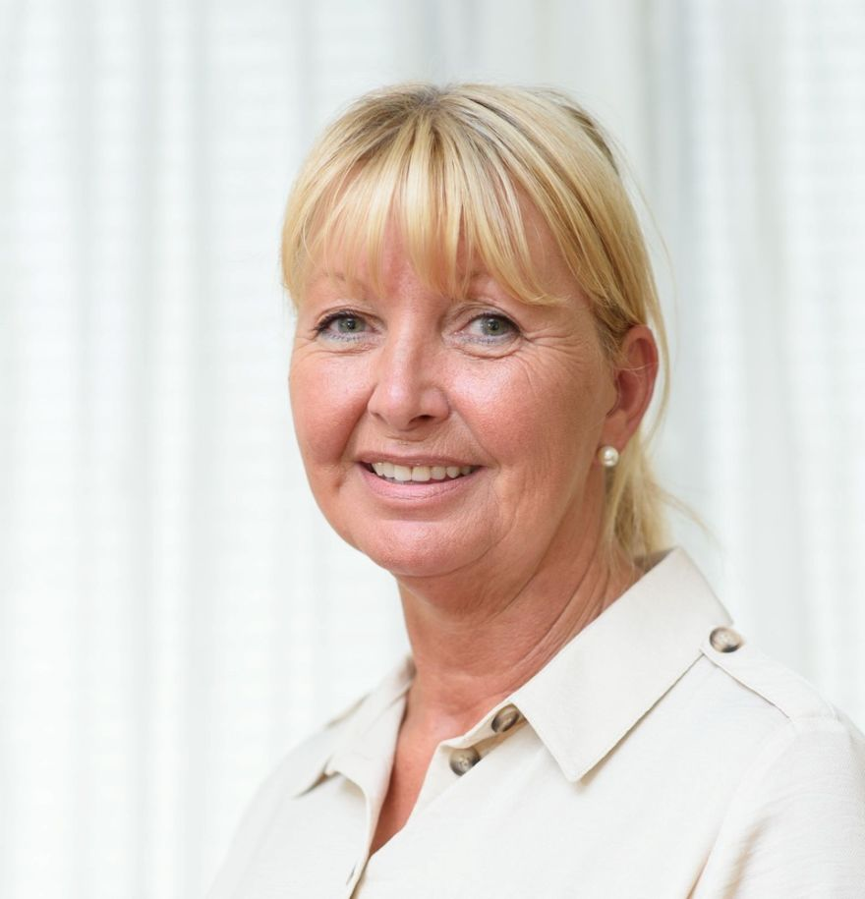

Sofia is a 50 year old nursing home manager, she works in Aveiro nursing home and started there as a caretaker. She really enjoys her work caring for the elderly, she’s loving and close with them.

Being a manager for the home she needs to constantly be up to date with the residents’ health state, for that the nursing home only has paper records that the caretakers update from time to time. This process can become bothering and slow if she has to see the evolution of a certain resident’s health, as she needs to go back and search for the older records. Although she loves her job she finds it hard to be in touch with all the residents, as she can’t go through all the records every day and personally see the residents at the same time.

She has tried storing the data digitally on her tablet for easier access, allowing for some interaction with the residents as she takes down their blood pressure or sugar level, however she still needs to write it for the paper records.

MOTIVATION: Have easy access to the health values of all her residents in one place and have it update easily.

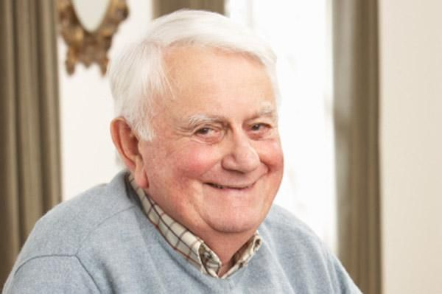

Julio is a 72 year old retired and married man, he used to work as a civil engineer and ended with 40 years of career. He has 2 sons and a daughter, and a total of 6 grandchildren, he’s generally a very happy man and loves his life.

He has some health complications however, since he has had diabetes for two decades and recently some hypertension problems. This leads him to often visit the doctor for checkups on his health where he measures various components of his health and evaluates him.

Often his children do the measurements at home for him since he needs to make sure he’s not going over any limits, however they don’t always know how to interpret the data directly from the machines. Julio downplays it and says it should be fine and they seemed similar to the ones at the doctor as to not be a hassle.

MOTIVATION: Julio wishes for a way to keep his health in check with professional evaluation without always having to be in the doctor.

<Uma Persona é uma personagem utilizada para contar histórias representativas da futura utilização do sistema. Uma Persona é um Actor instanciado, à qual se dá um conjunto de caraterísticas para a humanizar e definir o contexto em que usará o sistema e as suas motivações.

“Personas are fictional people. They have names, likenesses, clothes, occupations, families, friends, pets, possessions, and so forth. They have age, gender, ethnicity, educational achievement, and socioeconomic status. They have life stories, goals and tasks. Scenarios can be constructed around personas, but the personas come first. They are not ‘agents’ or ‘actors’ in a script, they are people. Photographs of the personas and their workplaces are created and displayed. […] It is to obtain a more powerful level of identification and engagement that enable design, development, and testing to move forward more effectively”. Adapted from Grudin, J. and Pruitt, J., 2002, June. Personas, participatory design and product development: An infrastructure for engagement. In Proc. PDC (Vol. 2).

Exemplo: ver [secção 4.1, neste artigo](http://www.mdpi.com/1424-8220/18/4/1285) (open access)] >

## Main scenarios

<You don’t need to be exhaustive. Pick the main scenarios, related to the core value of the system.>

<The scenarios tell the story of the Personas in their lives, doing their daily/professional activities that are relevant to find the points of contact with the system under specification.

Scenarios are somewhat similiar to use cases (they have a goal and tell a story), but, unlike use cases, they capture a larger process, with activities that may not use the software. Scenarios don’t required a “template”, like the usual use cases description.>

Exemplo: ver [secção 4.2 neste artigo](http://www.mdpi.com/1424-8220/18/4/1285) (open access)] >

# 3 Architecture notebook

## Key requirements and constraints

* The patients should be able to access the Web-App from remote PCs or Mobile Devices with internet connection.
* The users need to register themselves on the platform, in order to be able to access it. This includes providing personal information, such as an email address, password, full name, birth date, gender and, optionally, additional information related to health problems. This information will be stored on the database
* The Web-App should be available everyday, 24/7.
* When a user inserts a value, regarding his health trackers, the doctor should receive a notification about this update within 1 minute.
* <MORE TO ADD>

## Architectural view

The architecture of the project is mainly composed of four parts: the sensor layer, the Web app layer, the client side layer and the database layer.

The sensing layer will generate all the necessary information about the user and send it through message queues using RabbitMQ to the Web App, which after receiving the messages, processes them and forwards them to the database.

The database will be developed in mySQL, in order to be able to store information about each user and their sensors. The Web App will communicate directly with the database to obtain the information, and then transmit it to the user.

The Web App will be developed using Spring Boot, being able to communicate with the web page through a Web Controller, the communication with the Mobile App will be carried out through the Web App API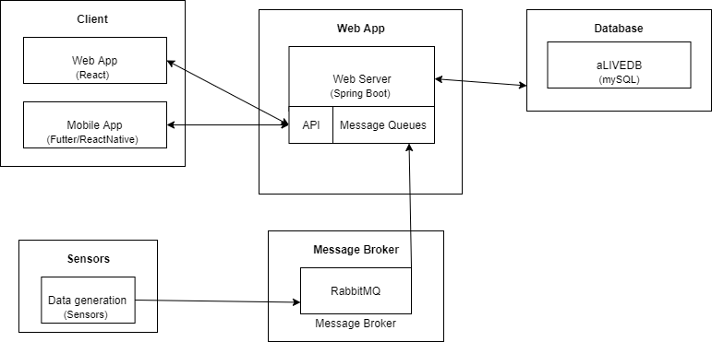

## Module interactions

→ explain how the identified modules will interact. Use sequence diagrams to clarify the interactions along time, when needed

→ discuss more advanced app design issues: integration with Internet-based external services, data synchronization strategy, distributed workflows, push notifications mechanism, distribution of updates to distributed devices, etc.>

# 4 Information perspective

<which concepts will be managed in this domain? How are they related?>

<use a logical model (UML classes) to explain the concepts of the domain and their attributes>

# 5 References and resources

<document the key components (e.g.: libraries, web services) or key references (e.g.: blog post) used that were really helpful and certainly would help other students pursuing a similar work>